This list shows all possible fields in my template “Change of Major”
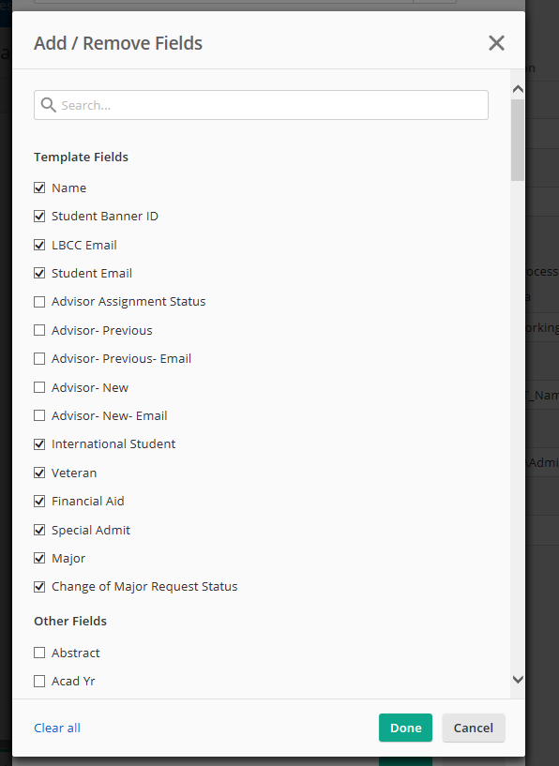
Of the fields above, these are the ones I have selected to show via the “Configure Fields” button in Save to Repository Task in Forms process. Note that I have removed a number of fields, i.e. “Advisor – Previous”
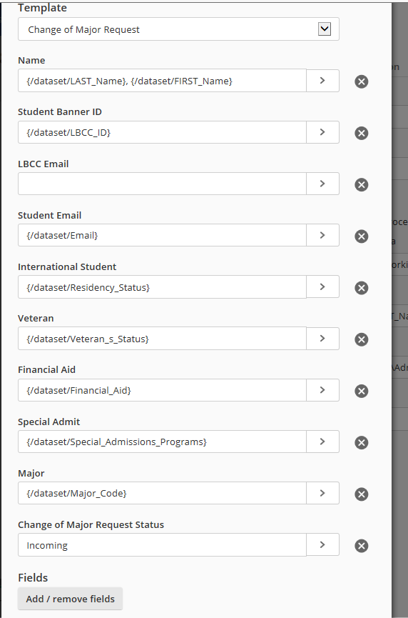

Here is my Forms process:
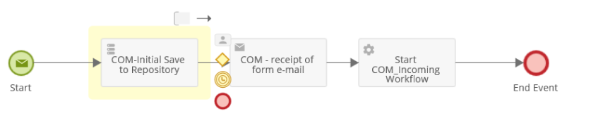

Here what I see when my workflow has stored the file into the repository. When the user opens the file with the metadata pane, these are Metadata fields that show up – which is every possible field from the template. Ideally, at this point in the process the user would see only the fields I selected on the page above. These “Advisor ….” fields would be hidden at this point so they don’t clutter up the user’s view.
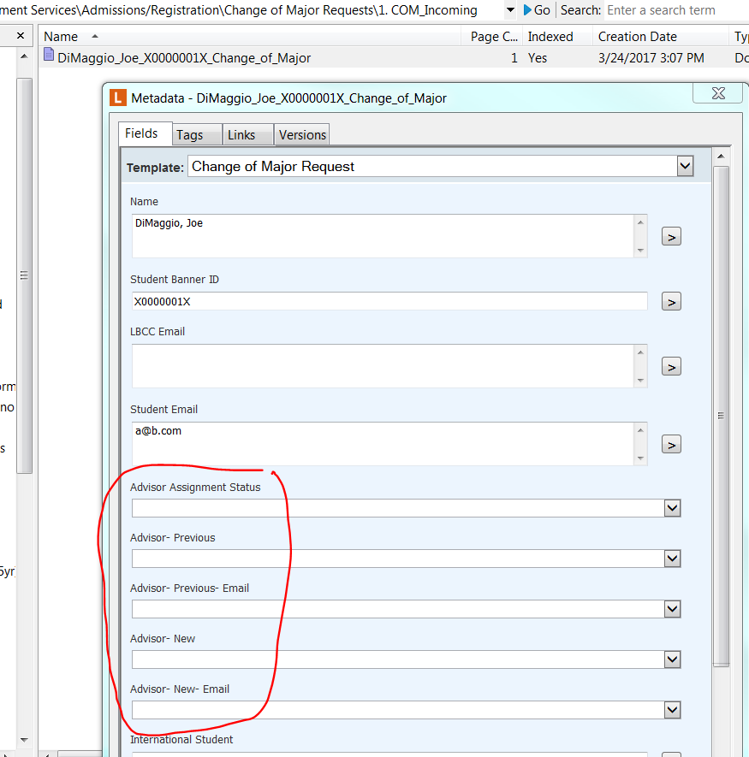

In a later step in the process, this file is directed to another folder. At that point, I will want these “Advisor …. “ fields to show up, and for some of the other fields to be hidden.

In case it helps, here is my first Workflow. The “Wait for Entry Change” tool is the one that is triggered when a specific metadata field from the template is populated and the file is saved.
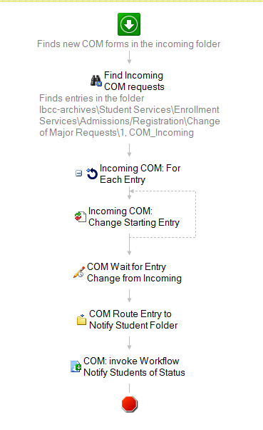

I have what seems like an odd question that I haven't been able to find an answer to. Here's my scenario/set up:
I have a Forms process that triggers a Workflow. The form is linked to a template that has a total of 15 metadata fields. Before the workflow is triggered, the Forms process files the form to a specific folder in the repository. Let's call this Folder A.
This form will ultimately go through a number of folders and associated workflows. In the initial workflow, there is a pause for a step that is triggered when a specific field in the template is altered. Our staff will open the form and the metadata pane from Folder A and, based on how they process the information in the form, they will select an option in a specific field in the template and save the file. This selection will trigger the initial workflow to proceed.
During this initial workflow, the staff member only needs to see 10 of the template's 15 fields; the rest of the fields will only be used in a later workflow. At the end of the initial workflow, the file is directed through a variety of additional repository folders and their associated workflows.
After some routing for emails and such, the file will ultimately land in a folder where it will be paused again. Let's call this Folder D. Once again, a user will open the file and the metadata pane. At this point, I would like the user to see the 5 fields that were hidden previously, and I want to hide some of the other 10. At the end of this step, the user will again select a specific option in a specific metadata field and save; this will trigger the workflow to resume.
So ultimately my question is this - is there a way to restrict which metadata fields show up when this file is viewed by a user in a specific folder? I would like them to be viewing just the data that is pertinent to the operation they are performing at the time. Because the template is so long, this will keep them from having to ignore metadata fields that are not involved in their particular task, as well as make it easier for them to locate the one they need to make a selection in that will move that workflow forward.
I have tried the following:
Used the "Configure Fields" option on the Save to Repository task within the Forms process; I have removed the fields from the template which do not need to be seen when the form hits Folder A in the repository.. While this looks like it works within the Forms process, when I go to the file in Folder A in the repository, all metadata fields are showing. Please see attached for screenshots.
A final comment is that my ultimate goal is that at each step of the process where a user has to open the file, I want to present them with just the data they need at that point, and in a manner that is easy to view and comprehend. The folks involved are used to pulling their information from columns in a spreadsheet. Working from the template and with metadata fields will be very different, and the less "cluttered" I can make it at each step, the better.
Thanks!

