# Workflow fires on wrong entry in path

These are the conditions that are set

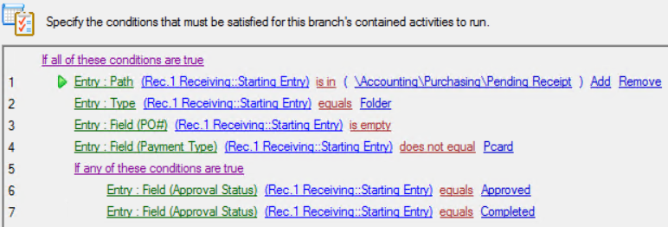

This is the “work packet” I am trying to move, note the Entry ID

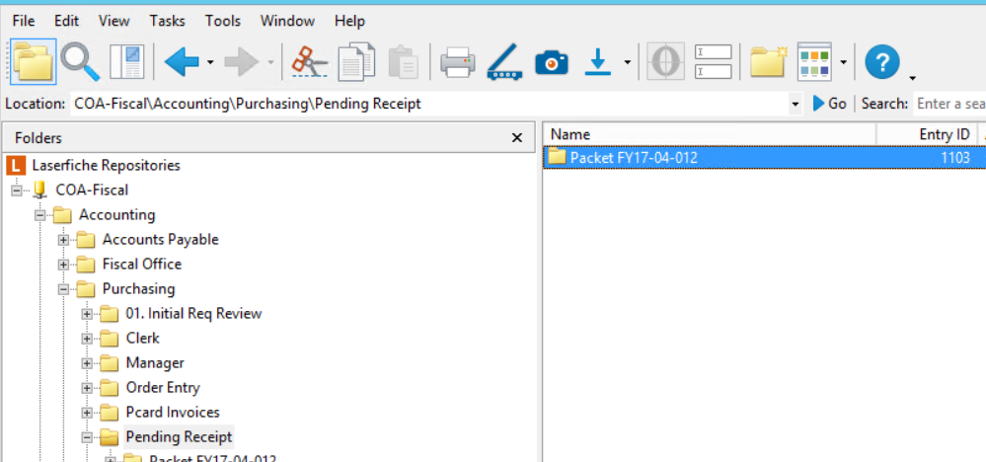

The workflow runs on the wrong folder, it runs on Entry ID 796. 796 is the root folder where the entry lives.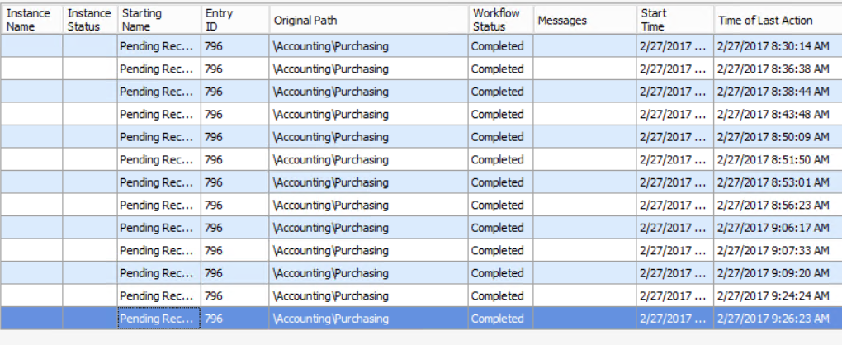

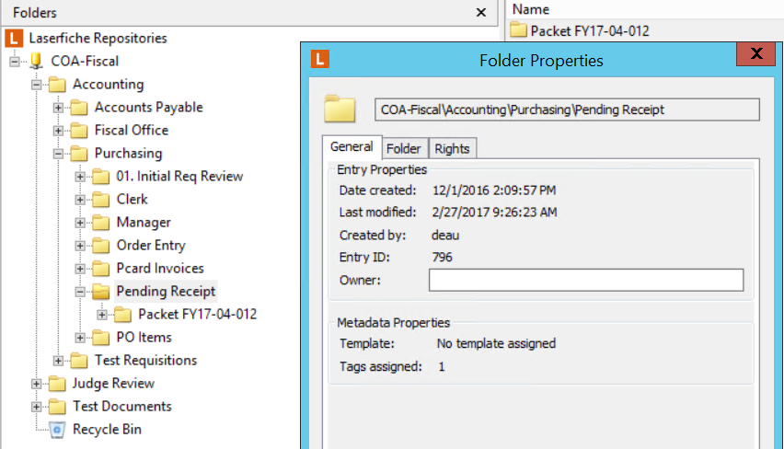

The workflow reports incorrectly that the condition was not met so does not pick up the entry. 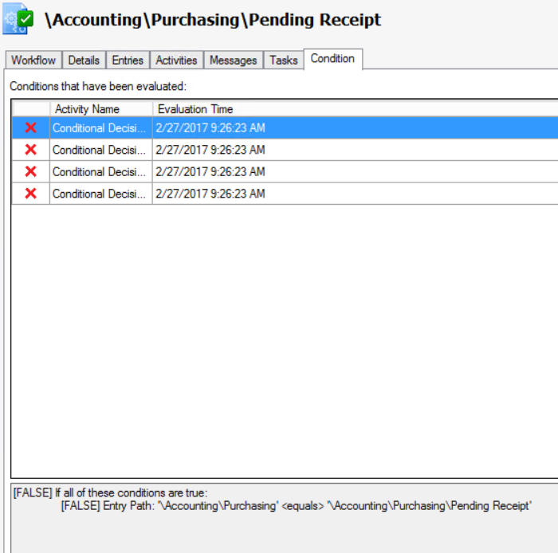 I have tried using path “equals”, “contains” and “is in” all without success.

We had a similar situation with another workflow and were able to resolve by deleting all the conditions restarting the workflow service and recreating the conditions. This one is not responding to that approach. I am open to all ideas but would much prefer being able to identify the root cause so hopefully will be able to avoid a repeat.