*Control Panels -> Programs and Features* lists right after uninstalling of LF client 10.2 in order to reproduce the Firefox extension issue of unattended installation of LF client 10.2:

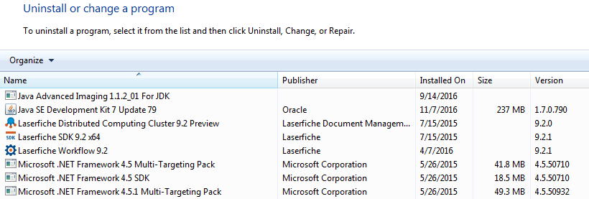

Dell KACE1000 Management Appliance Script window showing my unattended installation of LF Client 10.2:

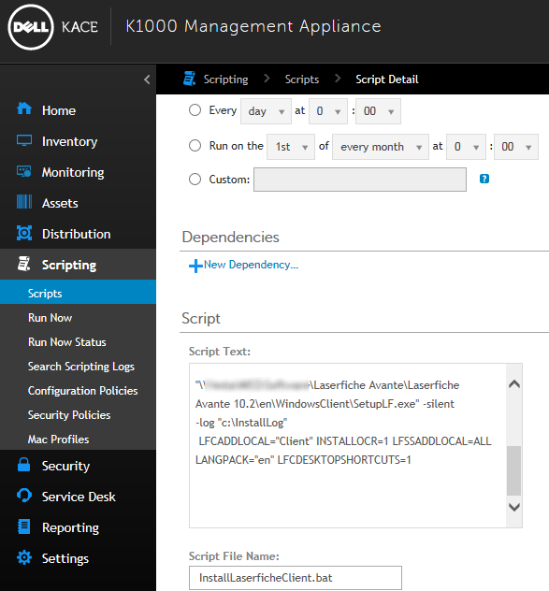

After starting the script, within a minute, the client icon shows up in my desktop:

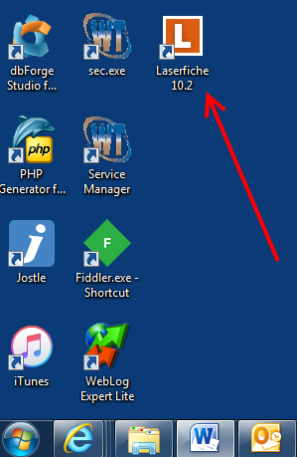

And “C:\InstallLog” folder gets many log files and none of them reports error when I checked: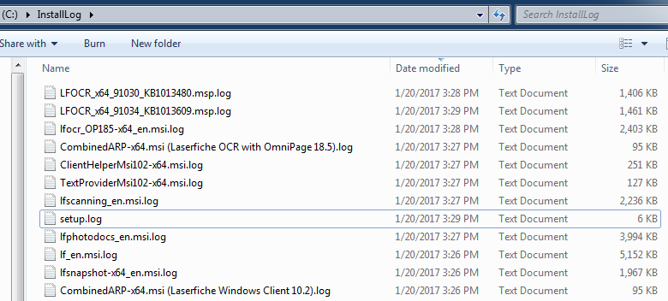

About 30 seconds after I see the newly installed LF client 10.2 icon, I get this “*Interactive Service Detection*” icon in the Windows Task Bar: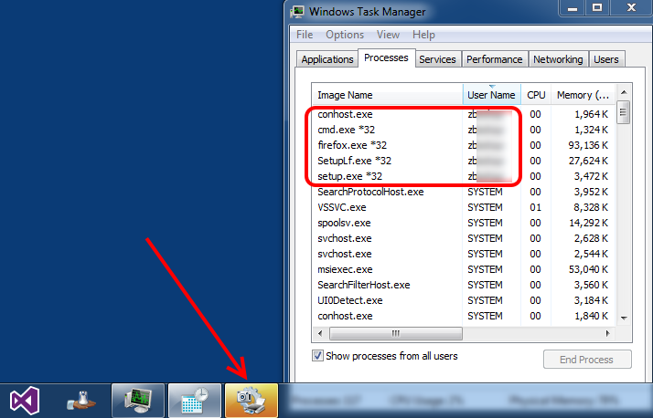

At this moment, the Task Manager shows 5 processes running by “zb\*\*\*\*” account which I set up in the KACE1000 as the script running credential.

When I open the “*Interactive Services Detection*” icon, it opens this dialog: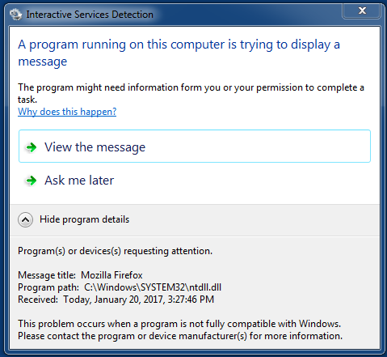

Click “*Why does this happen?”* link: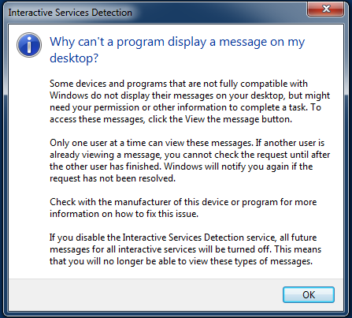

When I clicked “*View the Message*” link, Windows switches to a full screen mode. This is a photo of my two monitors: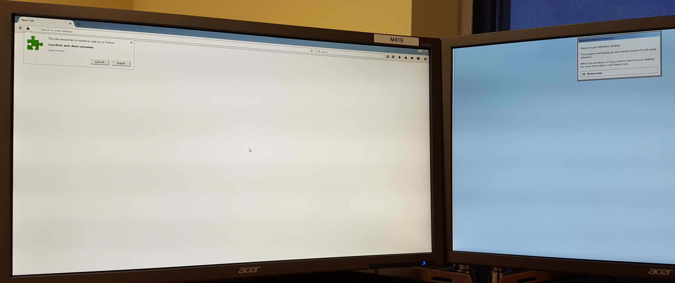

Zoomed up the left monitor: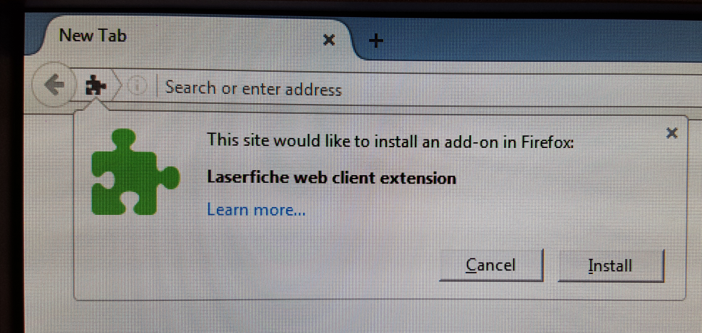

KACE1000 says it failed (probably because it timed out):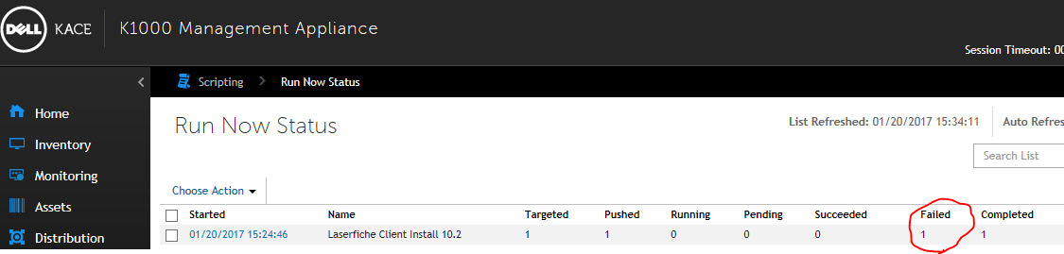

But my control panel shows all necessary LF client programs installed correctly: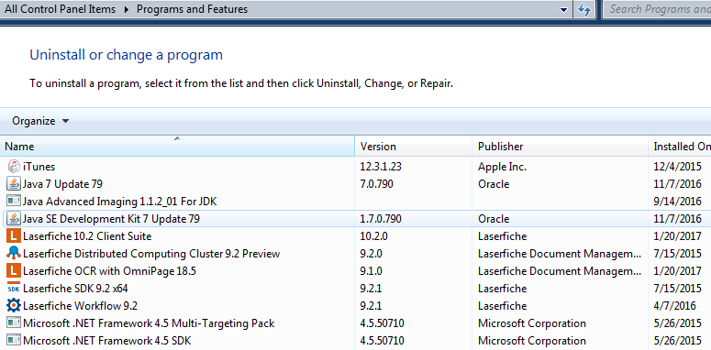



And when I click my desktop icon of LF Client 10.2, it seems all working fine. While I was checking the client, the “*Interactive Service Detection*” popped up again:

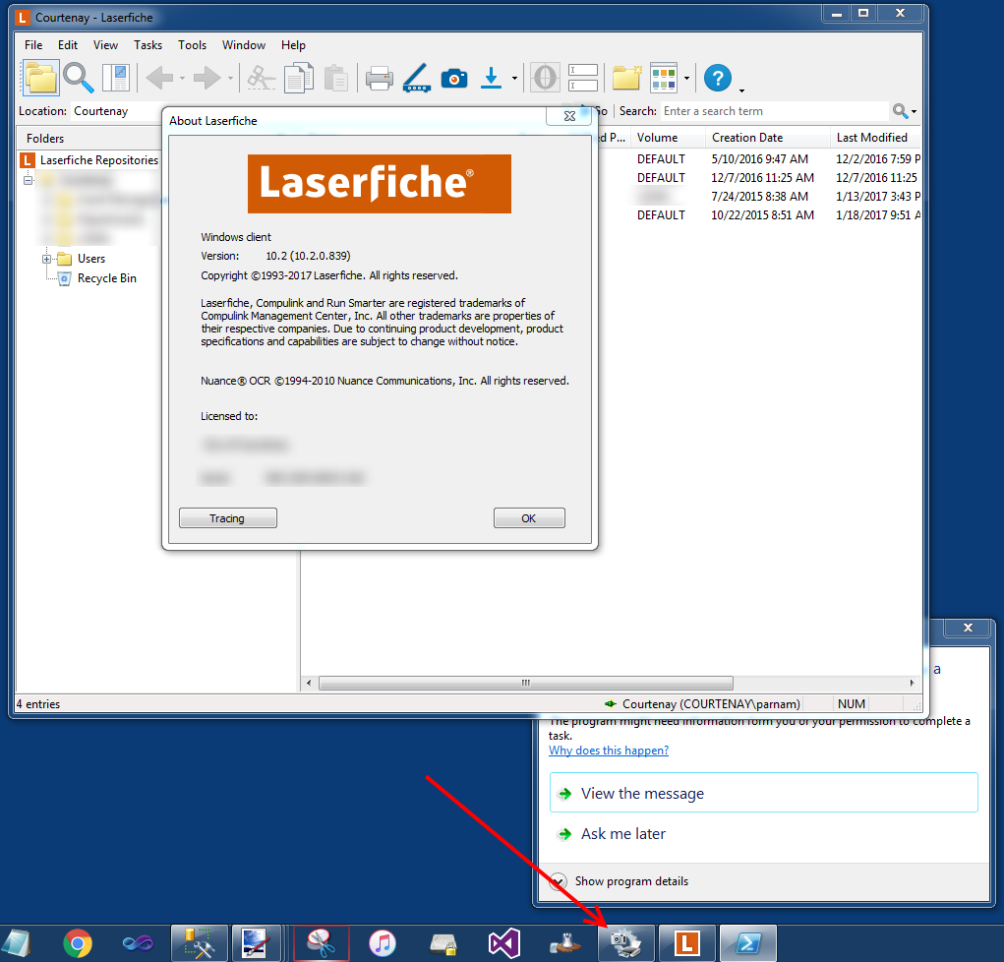

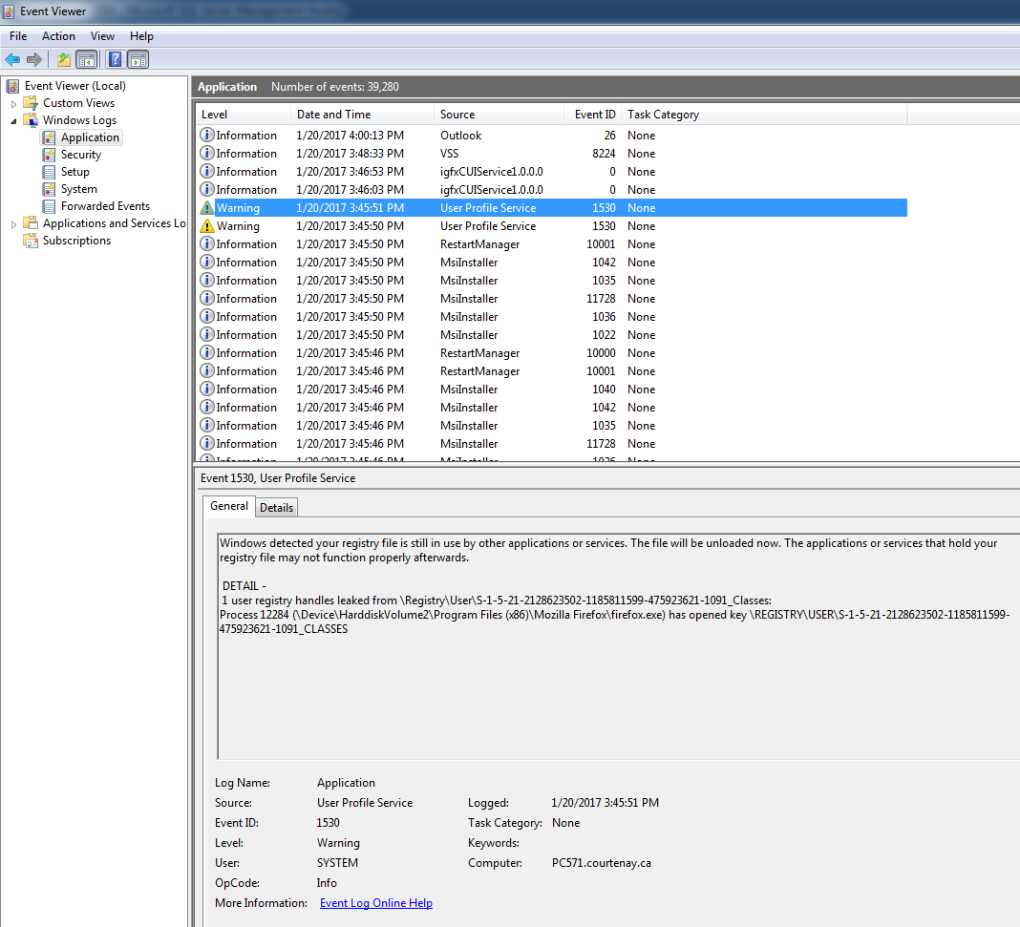

Operating System: Windows 7 Professional SP1 (64-bit)

Hardware spec: 8GB RAM Intel Core i7-4770S CPU

Database Server for LF: SQL Server Standard Edition SP3 (11.0.6020)