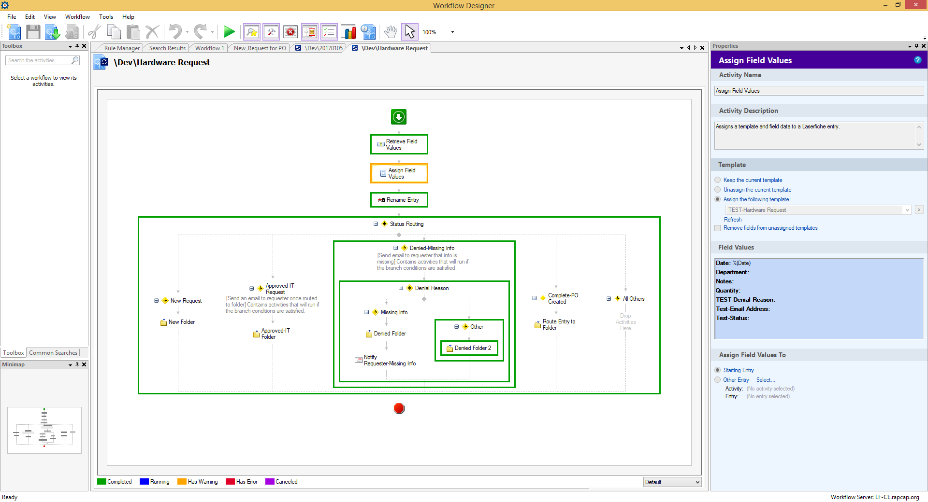

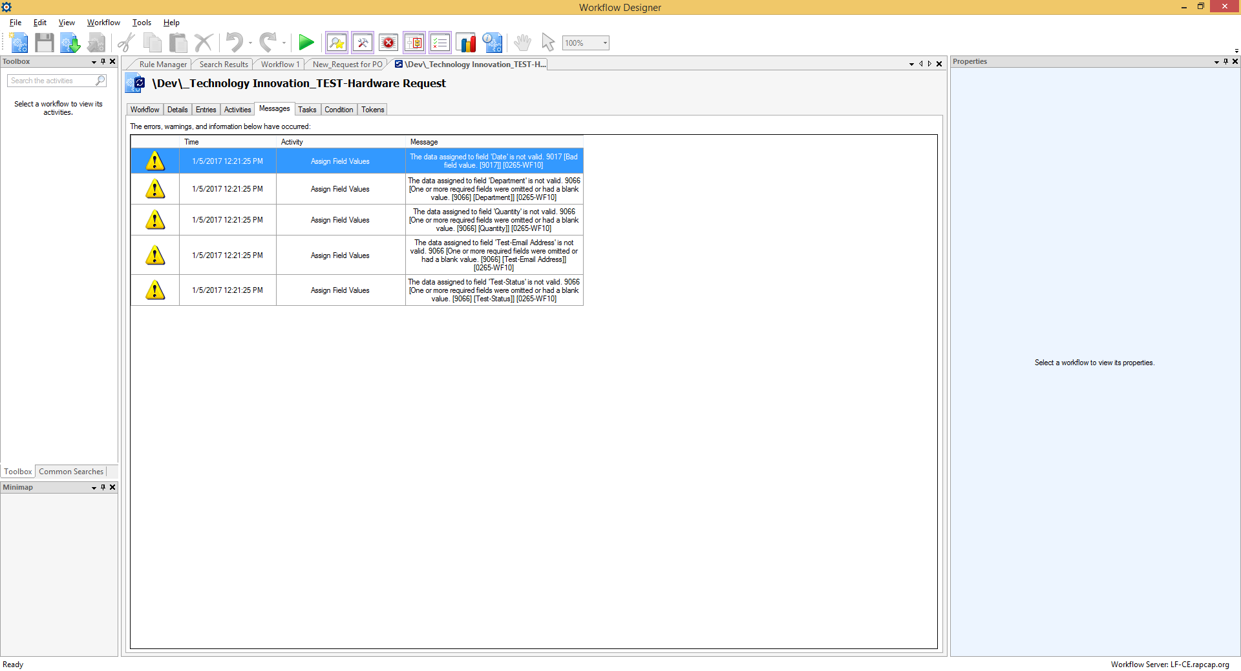

I get these error messages on Metadata fields in my template saying the value is invalid – but I’ve filled them in and the fields appear to be entered in correctly based on the formatting.

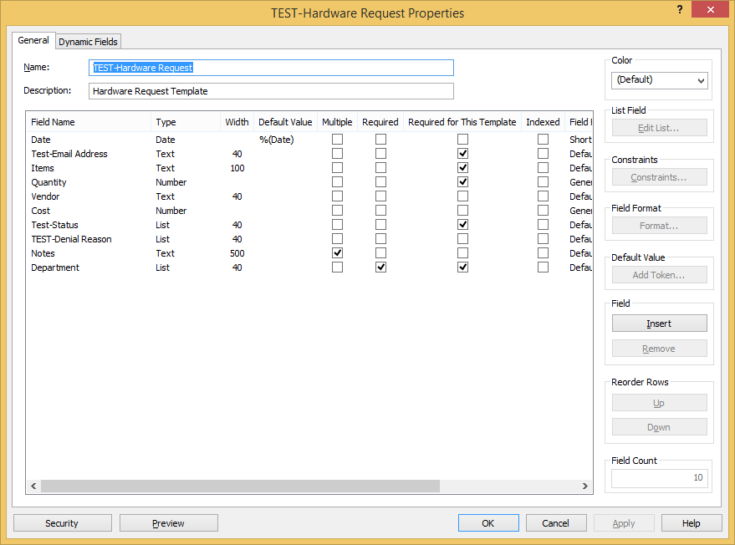

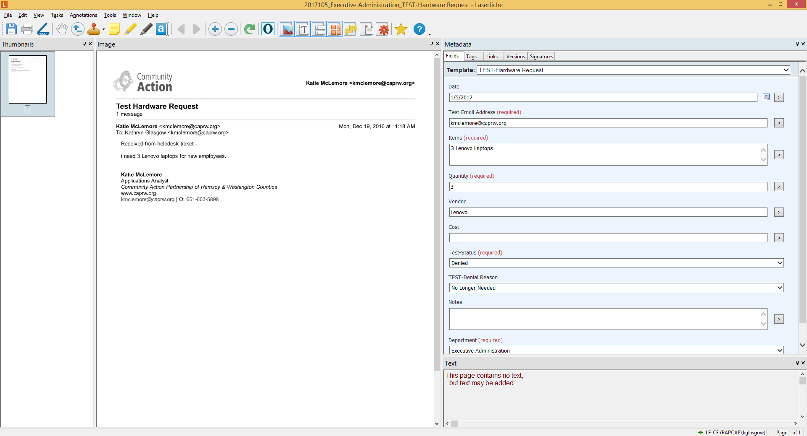

TEST-Denial Reason is being erased once I run the WF