## Set Network Load Balancing Cluster for Forms

1. Install Forms on each machine and configure them to connect to same database
2. Disable DHCP and use static IP address for each machine
   1. Open Control Panel, select Network and Internet
   2. Open properties for Ethernet, select Internet Protocol Version4(TCP/IPv4) and open properties for it and set the IP address to static

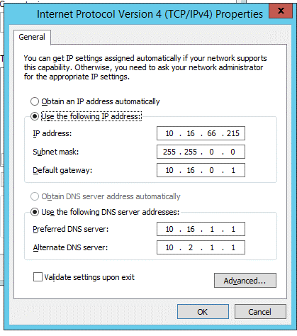

1. Install Network Load Balancing feature on each machine
   1. Open Server Manager
   2. Click Add roles and features
   3. Select “Network Load Balancing” on features step

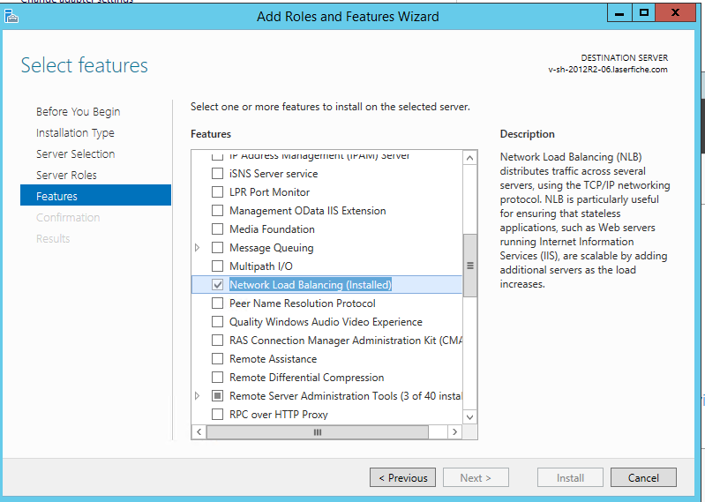

1. Follow <https://technet.microsoft.com/en-us/library/cc771008.aspx> to create a network load balancing cluster, make sure follow settings are correct.
   1. Cluster IP address: The virtual address for the cluster. It needs to be reserved in the DNS to ensure no other machine use it
   2. Full internet name: the FQDN name for the cluster. It needs to bind the FQDN with the cluster IP address in DNS.
   3. Cluster operation mode: Multicast
   4. Port rule affinity: Single. This is for preserving the session state so that each client’s traffic will be route to same server.

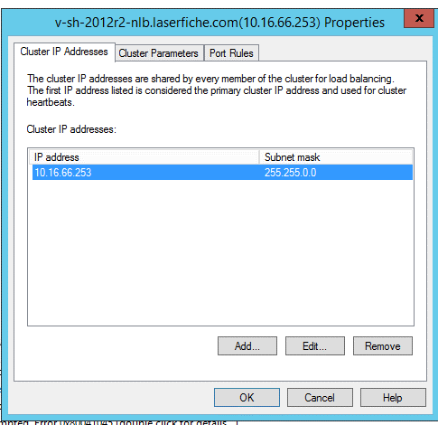

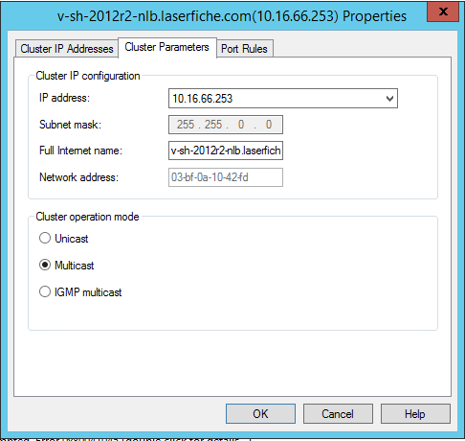

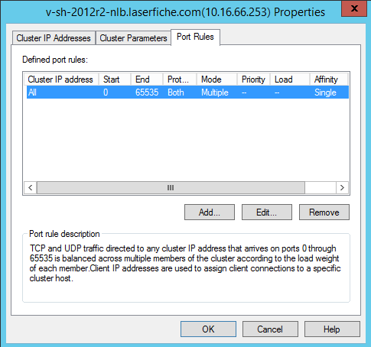

1. Follow <http://technet.microsoft.com/en-us/library/cc753744.aspx> to add a machine to the cluster. The network load balancing manager should look similar to the following:

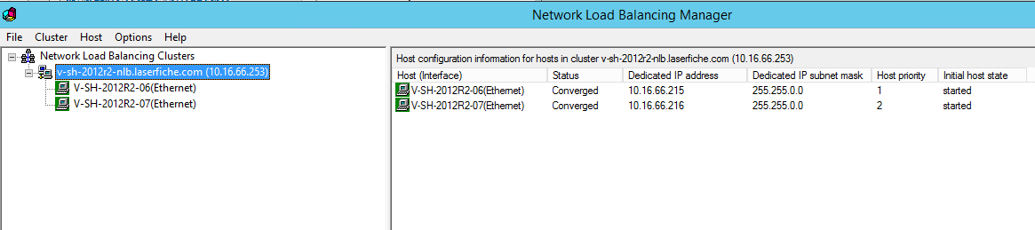

1. Add the cluster IP address as second IP Address for each machine
   1. Open Control Panel, select Network and Internet
   2. Open properties for Ethernet, select Internet Protocol Version4(TCP/IPv4) and open properties for it and click Advanced, add the cluster IP address as second IP address for the machine



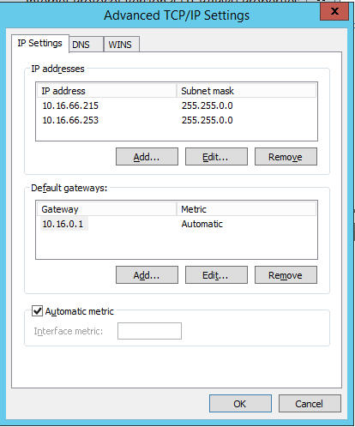

1. Go to Forms Configuration page from one Forms server and change Primary Forms Server URL to use the cluster IP address or cluster full internet name as the Forms server name

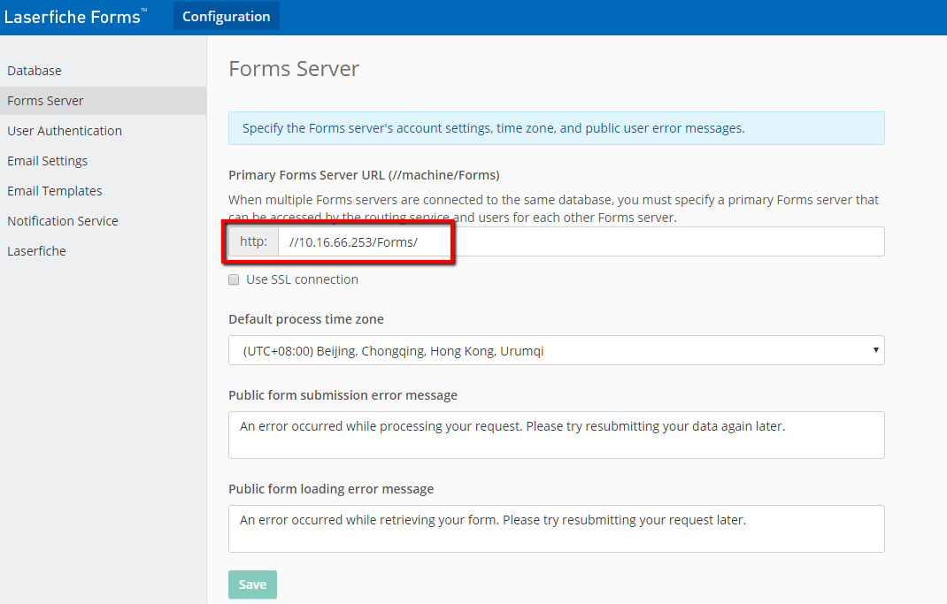

## Test Forms Network Load Balancing Cluster

1. Modify the file under C:\Program Files\Laserfiche\Laserfiche Forms\Forms\Views\Account\LogIn.cshtml and add unique string like <h2> xx </h2> for each forms server
2. Open Forms site using the cluster IP address from different machines and check sometimes it will load from machine 1 and sometimes it will load from machine 2

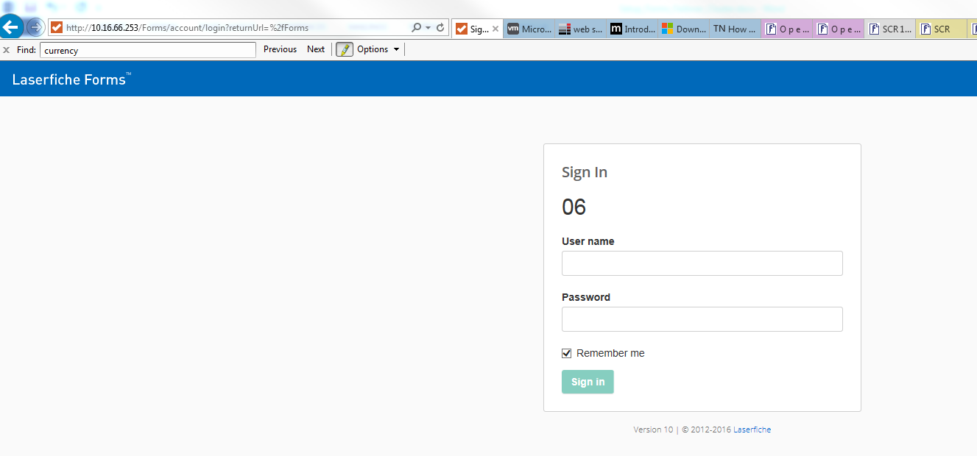

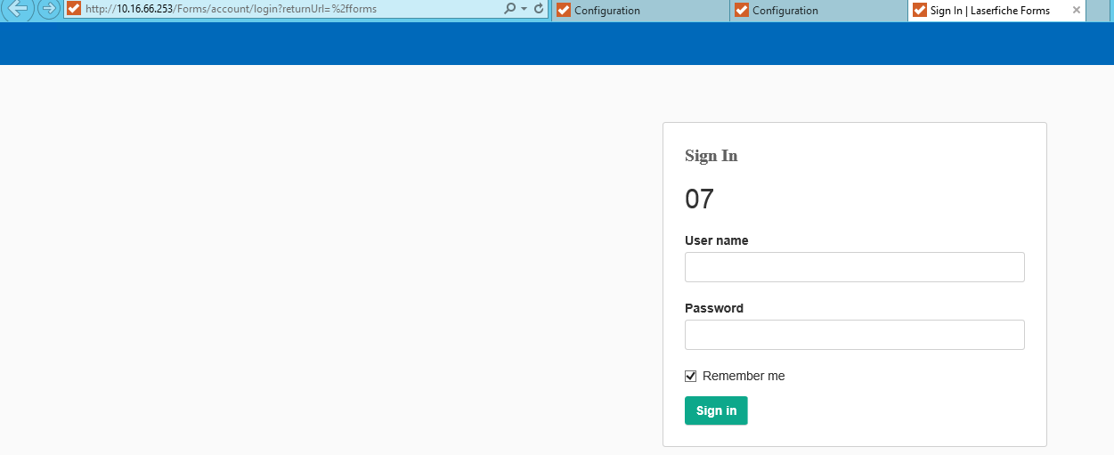

1. Login forms site and do some smoke test like submit a form, send email notification for task assignment, open task from email and approve, check the instance can be correctly processed.
2. Shutdown machine 1, check Forms site is still accessible when using cluster IP address or FQDN to visit.
3. Power on machine 1 and shutdown machine 2, check Forms site is still accessible when using cluster IP address or FQDN to visit.

Notes: The failover only works when the machine is down or the network for the machine is not accessible, it won’t work when the IIS is down. You can use System Center Management Pack for Windows Server Network Load Balancing (<https://www.microsoft.com/en-us/download/details.aspx?id=13302>) to monitor the cluster and make the failover work when IIS is down.

<https://msdn.microsoft.com/en-us/library/bb742455.aspx>

https://msdn.microsoft.com/en-us/library/cc756878(v=ws.10).aspx