1. Some documents with specific file structures give error 9013 in LF client.

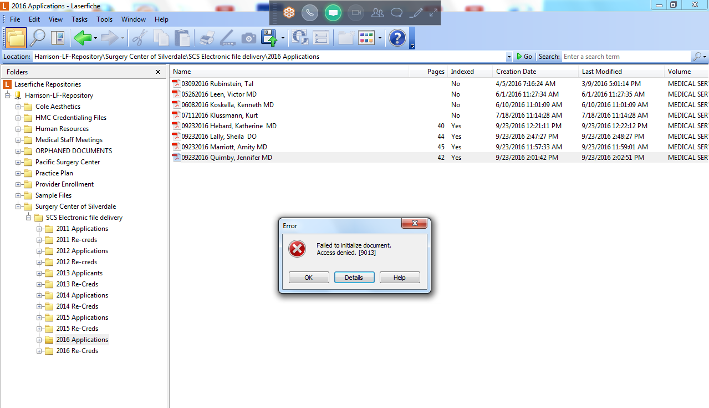

Details:

Error Code: 9013

Error Message: Failed to initialize document.

Access denied. [9013]

------------ Technical Details: ------------

LFSO:

Additional Details:

HRESULT: 0xc0042335 (LFSession::ProcessResponse, LFSession.cpp:3748)

(LFSO/9.0.2.660)

LF.exe (9.0.2.685):

Call Stack: (Current)

CLFDocument::AssignDocumentObject

CLFApp::OpenDocument

CFolderListCtrl::OpenItem

CFolderListCtrl::OpenItems

Additional Details:

Exception: 0xc0042335 [9013] (Permission denied.) (CLFDocument::AssignDocumentObject at LFDocument.cpp:1642)

Call History:

GetOptionString ([Settings]OpenEdocAsDoc)

CAttachedRepository::GetProfileValue

GetOptionString ([Settings]OpenPDFAsDoc)

CAttachedRepository::GetProfileValue

GetOptionString ([Settings]OpenPagelessWithMetadataDlg)

CAttachedRepository::GetProfileValue

CLFDocument::AssignDocumentObject

CLFDocument::GetDocumentVersion

1. Moving Migrated documents on the old LF Volumes location fails:

