Multiple repository creation Issue

We have one application server (Win 2008 R2 server ) where 1 repository is in place which connects to SQL 2008 ( Win 2008 R2 server ), now we have 1 new WIN 2012 server having sql 2016 database instance and we are trying to create a repository against this database on same application server.

Initially we needed to update the UUID for this database so as per instructions from LF support we have installed SQL native client 2012 on application server and updated the UUID for it. So connection to sql 2016 was successful from application server.

Now when we go ahead and cerate the repository we are not able to see any database in drop down list. If we enter the name manually or try to create a new database itself its gives error as below.

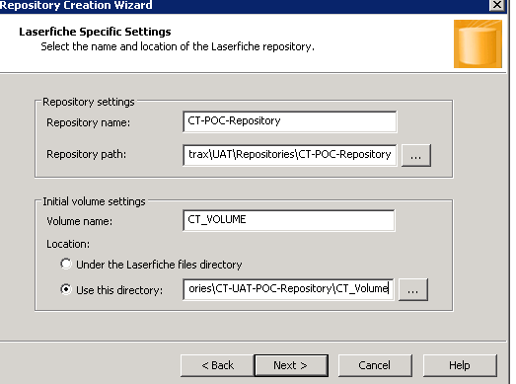

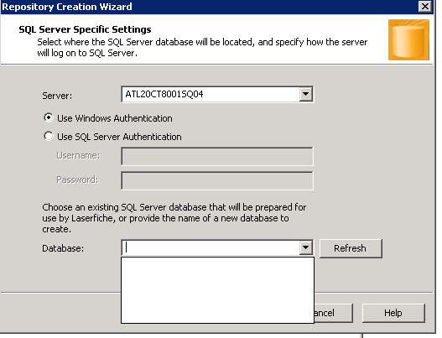

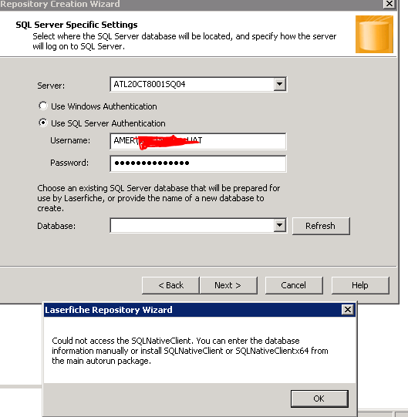

And if we give name manually of created repository or allow LF to create a new repository database itself it gives below error.

