# Workflow Configuration Manager Errors

I am trying to configure a repository to be managed and am getting some errors. See screenshots below.

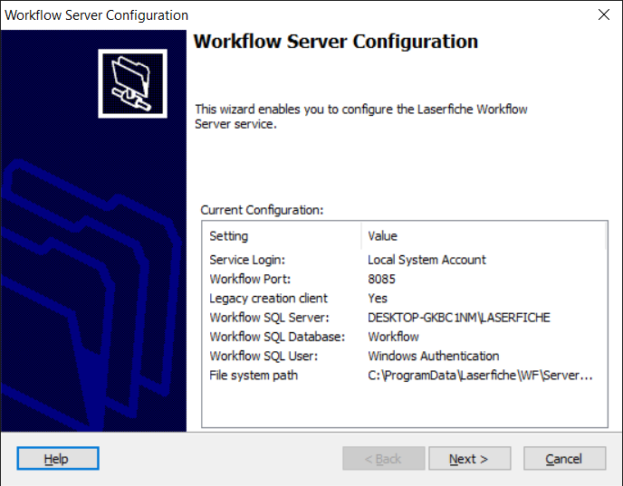

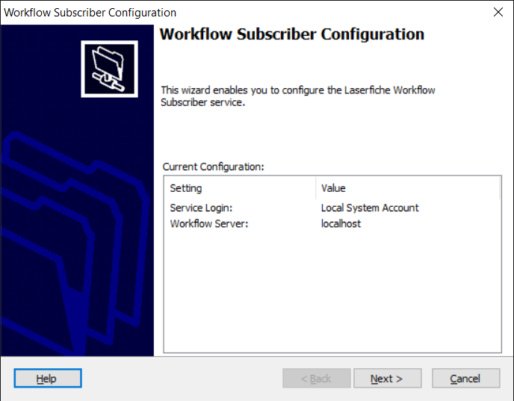

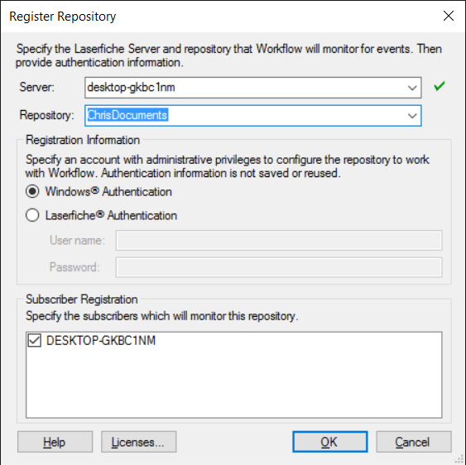

I get the following error when using “Windows Authentication”

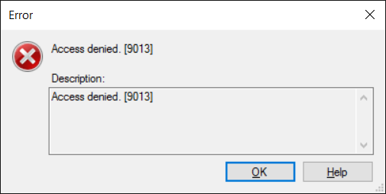

If I choose “LF Authentication” and use username/password admin/admin I get this error.

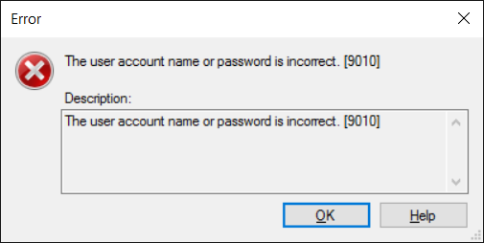

If I instead choose “LaserRepository” with “LF Authentication” I get this warning.

